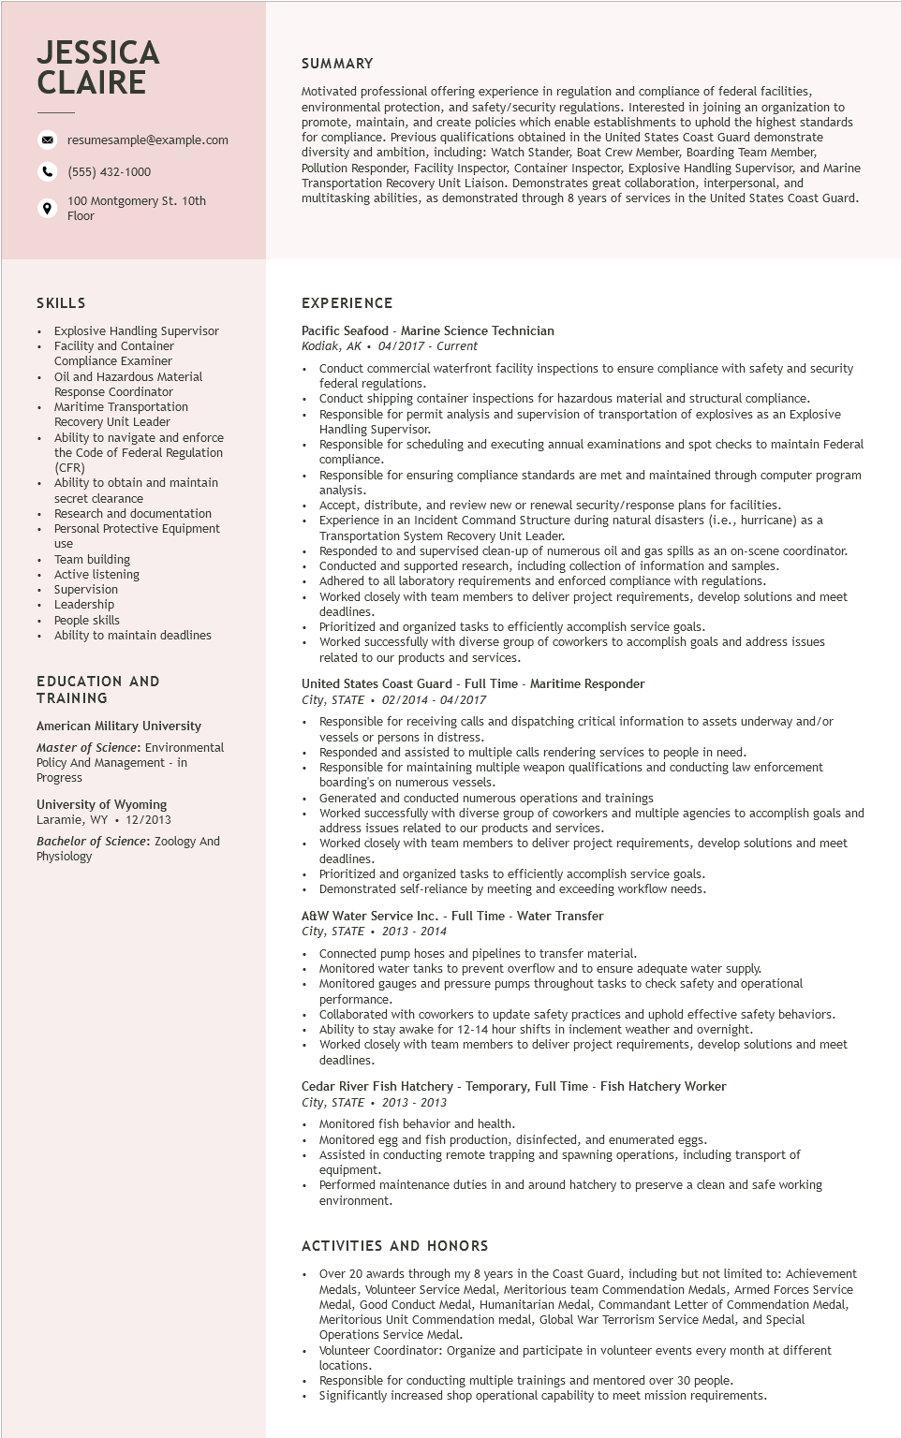
JESSICA CLAIRE
resumesample@example.com
(555) 432-1000
100 Montgomery St. 10th Floor
SUMMARY
Motivated professional offering experience in regulation and compliance of federal facilities, environmental protection, and safety/security regulations. Interested in joining an organization to promote, maintain, and create policies which enable establishments to uphold the highest standards for compliance. Previous qualifications obtained in the United States Coast Guard demonstrate diversity and ambition, including: Watch Stander, Boat Crew Member, Boarding Team Member, Pollution Responder, Facility Inspector, Container Inspector, Explosive Handling Supervisor, and Marine Transportation Recovery Unit Liaison. Demonstrates great collaboration, interpersonal, and multitasking abilities, as demonstrated through 8 years of services in the United States Coast Guard.
SKILLS
Explosive Handling Supervisor Facility and Container
Compliance Examiner
Oil and Hazardous Material Response Coordinator
Maritime Transportation Recovery Unit Leader
• Ability to navigate and enforce the Code of Federal Regulation (CFR)
Ability to obtain and maintain secret clearance
Research and documentation
• Personal Protective Equipment
use
Team building Active listening
• Supervision
• Leadership
• People skills
• Ability to maintain deadlines
EDUCATION AND TRAINING
American Military University Master of Science: Environmental Policy And Management - in Progress
University of Wyoming
Laramie, WY
12/2013
Bachelor of Science: Zoology And Physiology
EXPERIENCE
Pacific Seafood - Marine Science Technician
Kodiak, AK⚫ 04/2017 - Current
•
Conduct commercial waterfront facility inspections to ensure compliance with safety and security federal regulations.
Conduct shipping container inspections for hazardous material and structural compliance.
• Responsible for permit analysis and supervision of transportation of explosives as an Explosive Handling Supervisor.
Responsible for scheduling and executing annual examinations and spot checks to maintain Federal compliance.
Responsible for ensuring compliance standards are met and maintained through computer program analysis. Matysis.
Accept, distribute, and review new or renewal security/response plans for facilities.
Experience in an Incident Command Structure during natural disasters (i.e., hurricane) as a Transportation System Recovery Unit Leader.
Responded to and supervised clean-up of numerous oil and gas spills as an on-scene coordinator. Respon Conducted and supported research, including collection of information and samples. Adhered to all laboratory requirements and enforced compliance with regulations.
Worked closely with team members to deliver project requirements, develop solutions and meet deadlines.
Prioritized and organized tasks to efficiently accomplish service goals.
Worked successfully with diverse group of coworkers to accomplish goals and address issues related to our products and services.
United States Coast Guard - Full Time - Maritime Responder
City, STATE 02/2014 - 04/2017
Responsible for receiving calls and dispatching critical information to assets underway and/or vessels or persons in distress.
Responded and assisted to multiple calls rendering services to people in need.
Responsible for maintaining multiple weapon qualifications and conducting law enforcement boarding's on numerous vessels.
Generated and conducted numerous operations and trainings
Worked successfully with diverse group of coworkers and multiple agencies to accomplish goals and address issues related to our products and services.
Worked closely with team members to deliver project requirements, develop solutions and meet deadlines.
Prioritized and organized tasks to efficiently accomplish service goals.
Demonstrated self-reliance by meeting and exceeding workflow needs.
A&W Water Service Inc. - Full Time - Water Transfer
City, STATE 2013 - 2014
.
Connected pump hoses and pipelines to transfer material.
• Monitored water tanks to prevent overflow and to ensure adequate water supply.
• Monitored gauges and pressure pumps throughout tasks to check safety and operational performance.
• Collaborated with coworkers to update safety practices and uphold effective safety behaviors.
• Ability to stay awake for 12-14 hour shifts in inclement weather and overnight.
Worked closely with team members to deliver project requirements, develop solutions and meet deadlines.
Cedar River Fish Hatchery - Temporary, Full Time - Fish Hatchery Worker
City, STATE 2013 - 2013
Monitored fish behavior and health.
Monitored egg and fish production, disinfected, and enumerated eggs.
Assisted in conducting remote trapping and spawning operations, including transport of equipment.
Performed maintenance duties in and around hatchery to preserve a clean and safe working environment.
ACTIVITIES AND HONORS
Over 20 awards through my 8 years in the Coast Guard, including but not limited to: Achievement Medals, Volunteer Service Medal, Meritorious team Commendation Medals, Armed Forces Service Medal, Good Conduct Medal, Humanitarian Medal, Commandant Letter of Commendation Medal, Meritorious Unit Commendation medal, Global War Terrorism Service Medal, and Special Operations Service Medal.
Volunteer Coordinator: Organize and participate in volunteer events every month at different locations.
Responsible for conducting multiple trainings and mentored over 30 people.
Significantly increased shop operational capability to meet mission requirements.

